**Experiment-2**

**Aim: Working with Docker (Basic Commands)**

1. Search for an image on Docker Hub like: python

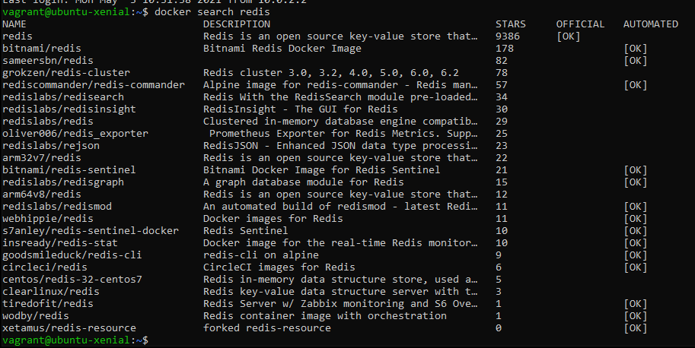

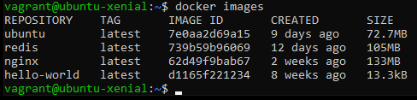

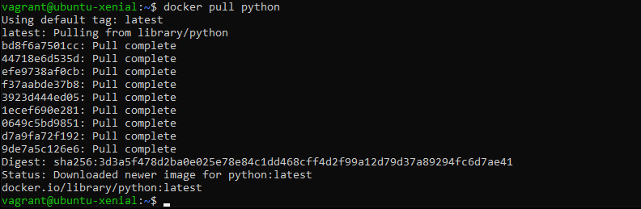

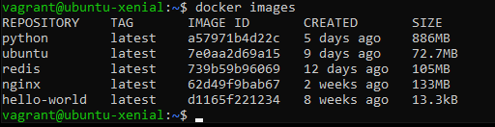

1. Run Docker Conatiner of Redis image in background

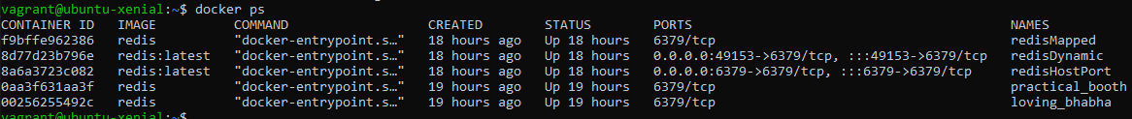



1. Run Docker ps and Docker ps -a

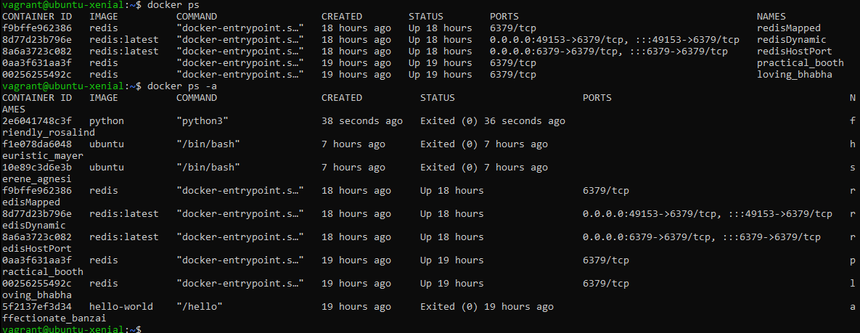

1. Run Docker Container and take its console.

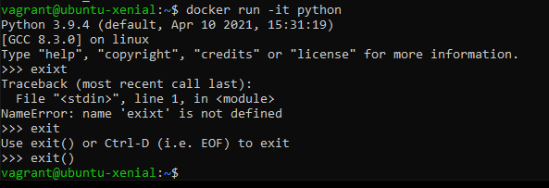

So once we run the command **docker run –it <image_name>,** terminal opens up and we can create files in it. But as soon as container is exited the data will no longer exist. As shown below.

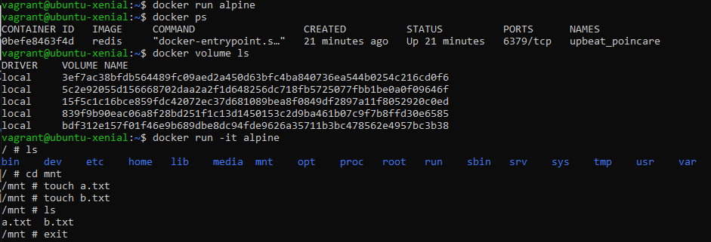

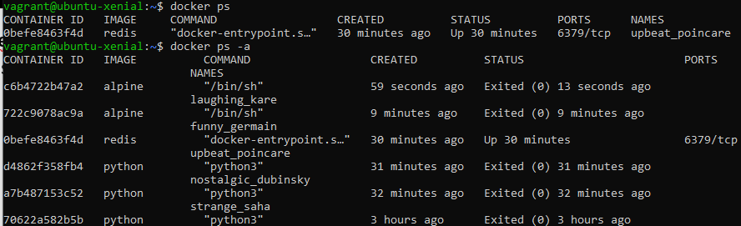

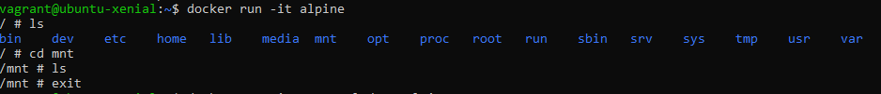

So to save all that data when we are making the container we are supposed to give the container a volume that will help us to keep our data safe.

This would be done by the command **docker run –it –v <volume_name>:/<file_name> <image_name>**. As shown below.

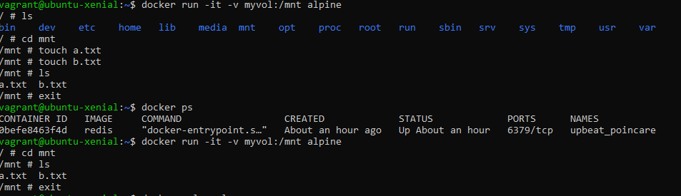

This is how you create Docker Volume and Connect it.  
  
The volume has the location in the root folder and to find the path we have command

**docker volume inspect <volume_name>**As shown below.  
